# Blerdy Womanist – Design Brief

**Blerdy Definition**

* A combination of the words “Black” and “Nerd”. In essence a black nerd.

**Womanist Definition**

* A black feminist or feminist of colour who is committed to the wholeness and well-being of all humanity.
* A womanist is a woman who loves women and appreciates women’s culture and power as something that is incorporated into the world as a whole.
* Womanist recognise the beauty and strength of embodied black womanhood and seek connections and solidarity with black men.

**Blerdy Womanist Mission**

* Connecting Black Nerds who simultaneously identifies as a womanist.
* Committed in empowering women of colour in the technology industry.
* Increasing visibility of women in colour in the tech industry.
* Educate women of colour the different roles available in tech.
* Inspiring the future generation to consider technology.

**Why?**

* Lack of black and women of colour in the technology industry.
* Lack of black and women of colour representing technology on YouTube.
* Blerdy Womanist aims to create tutorials, interviews and vlogs of technology conferences.

**Logo Idea**

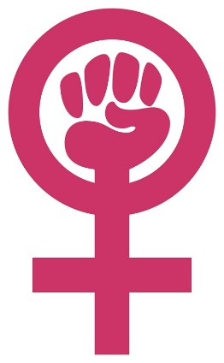

* The logo needs to incorporate the Venus symbol, which represent women.
* The black power fist needs to be included in the design too.
* The focus is technology – maybe incorporate binary code into the logo?
* The colours need to represent empowerment, cutting edge and wisdom.